**ITSE 1330 – Intro to C#**

**Module 2 - Project 2**

**There are 3 projects for this Module. Place both project folders in a folder called FirstnameLastnameCSMod2. When you are done with all 3 projects, zip the folder and submit via Moodle. DO NOT ZIP EACH INDIVIDUAL PROJECT, only the outer folder.**

*Create a Windows Forms application named* ***FirstNameLastName2A***

*Save the application in the FirstnameLastnameCSMod2 folder.*

Create a project that allows the user to enter a car’s speed in miles per hour. The application should have buttons that display the following:

Distance car will travel in 5 hours

Distance car will travel in 8 hours

Distance car will travel in 12 hours

Use a textbox and label to get the information from the user. The distance should show up in a label when each button is clicked. There should also be a working clear button and an exit button.

Example Form:

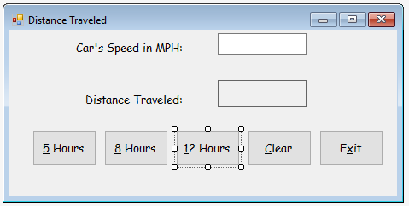

*Create a Windows Forms application named* ***FirstNameLastName2B***

*Save the application in the FirstnameLastnameCSMod2 folder.*

Create an application with a form similar to the one pictured below. When the application starts, the user will click the buttons to build a sentence (each word you add should be added to what is in the label, so it makes a sentence, not just each separate word), which should show in a label control. The Reset button should clear the sentence so the user can start over. Change the background color of the button to blue when/if it is clicked one or more times. Change the background color of the form to green when the Reset button is clicked. Make sure the tab order is set. There should also be a working exit button.

Example Form:

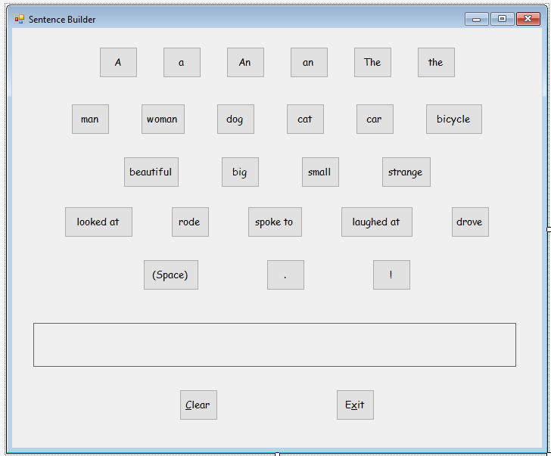

*Create a Windows Forms application named* ***FirstNameLastName2C***

*Save the application in the FirstnameLastnameCSMod2 folder.*

Create an application with a form similar to the one below. The PictureBox controls should display the images of the four fruits (a banana, an apple, an orange, and a pear) and each fruit’s calories. When the application starts, the total calories displayed should be zero. Each time the user clicks one of the PictureBoxes, the calories for that fruit should be added to the total calories, and the total calories should be displayed in a label. When the user clicks the orange the background of the total calories result label should change to orange, when they click the pear it should change to green, banana should change to yellow and cherry to red. When the user clicks the Reset button, the total calories should be reset to zero. There should also be a working exit button.

Example Form:

